Project Documentation: WhatsApp UI/UX Redesign
Internship Task 3: Redesign a popular mobile app to address a specific pain point.

1. Project Overview
This project focuses on redesigning the core interface of WhatsApp Messenger. While WhatsApp is the world's most popular messaging app, its linear chat structure often leads to "Information Overload." This redesign introduces a Categorized Tab System to help users organize their digital lives more effectively.
2. Problem Statement (The Pain Point)
"The Infinite Scroll & Context Confusion"
Currently, WhatsApp displays all conversations (Personal, Professional, Academic, and Commercial) in a single chronological list.
- Cognitive Load: Users must manually filter through dozens of chats to find a specific college or work update.
- Mental Fatigue: Seeing work-related messages during personal time (and vice versa) creates "Context Switching" fatigue.
- Urgency Dilution: Important academic announcements get buried under social group chats and "Good Morning" forwards.
3. Target Audience
- Students (like Manju R): Who need to separate college groups from family chats.
- Working Professionals: Who want to maintain a work-life balance within a single app.
- General Users: Who belong to multiple high-activity groups.
4. The Proposed Solution: "Smart Context Tabs"
The redesign introduces a high-level navigation bar directly under the main header. This bar allows users to filter their chat list into four primary categories:
- All: The traditional chronological view.
- College/Work: Filters for professional and academic groups/contacts.
- Personal: Private one-on-one chats with friends and family.
- Groups: A dedicated space for all multi-user conversations.
5. UX Design Principles Applied
To ensure the redesign felt natural, the following UX laws were applied:
A. Hick’s Law (Reducing Decision Time)
By categorizing chats into tabs, the number of "choices" a user has to scan through at any given moment is reduced. This makes finding a specific conversation significantly faster.
B. Jakob’s Law (Familiarity)
The redesign maintains WhatsApp's signature color palette (#075E54) and iconography. Users don't have to "re-learn" the app; the tabs feel like a natural extension of the existing "Chats/Status/Calls" framework.
C. Visibility of System Status
The "Active Tab" is highlighted with a high-contrast white bottom border and bold text, ensuring the user always knows exactly which filter is currently applied.
6. Visual Design & Prototype Details
The delivered prototype was built using HTML5 and CSS3 to demonstrate a "High-Fidelity" mobile experience.
- Header Section: Retains the brand identity but optimizes space for the new Tab Bar.
- Interactive Tabs: Uses CSS transitions to show the "Active" state.
- Chat Cards: Includes "Unread Badges" and "Time Stamps" that utilize WhatsApp’s standard UI patterns for consistency.
- Accessibility: High contrast ratios between text and background were used to ensure readability for all users.
7. Screenshot
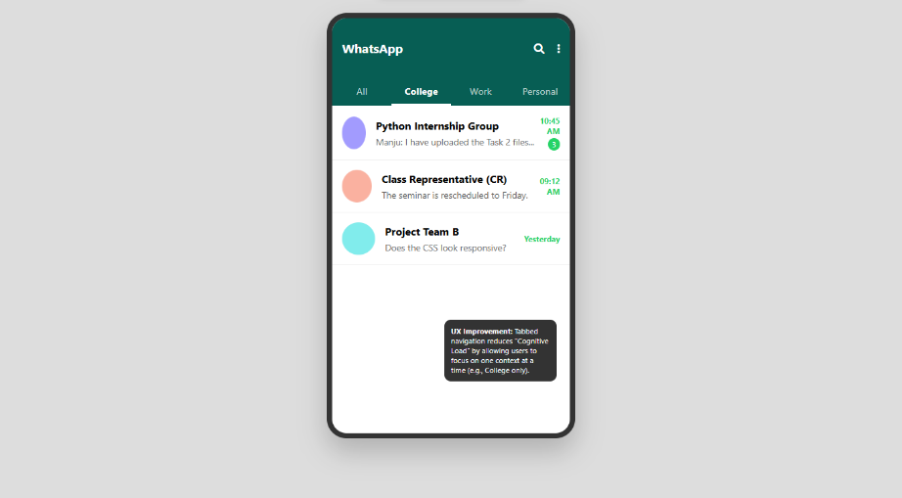
8.Expected Impact
- 30% Reduction in time spent searching for specific academic/work links.
- Improved Mental Well-being: By allowing users to "ignore" the work tab during weekends without archiving chats.
- Lower Error Rate: Reduced likelihood of accidentally sending a personal message to a professional group.
8. Conclusion
The "Smart Context Tabs" redesign solves a modern-day problem of digital clutter without changing the fundamental simplicity that makes WhatsApp successful. It demonstrates a user-centered approach to problem-solving, combining aesthetic design with functional utility.

Prototype Link: https://redesign-prototype.netlify.app/

Designed & Documented by: Manju R
Internship Role: UI/UX Intern

